Chinese Junks Sampans, Shanghai River
Attributed to John Thomson | ca. 1865 | Record IMG-EA0002

1. Original Image
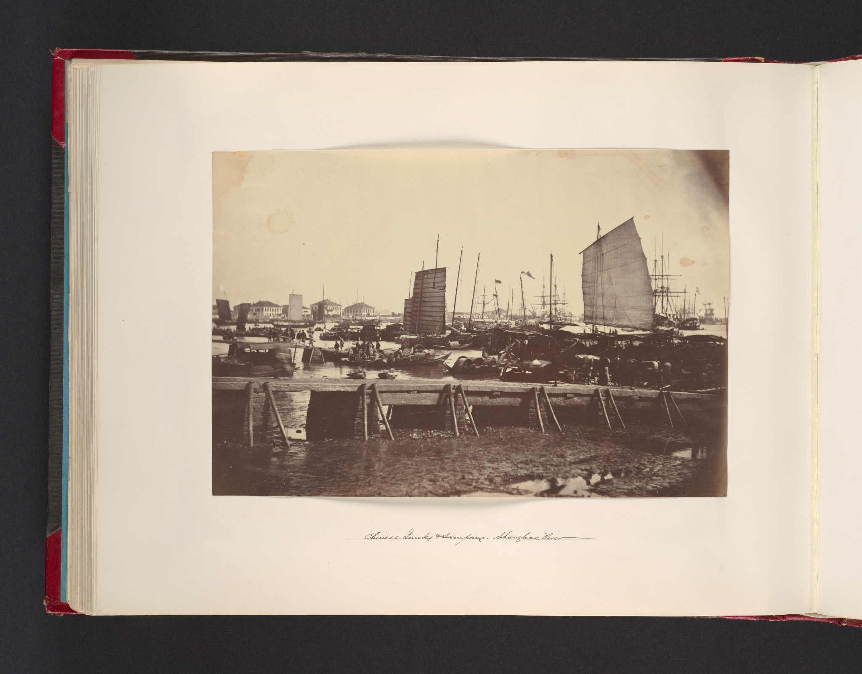
IMG-EA0002. John Thomson, Chinese Junks Sampans, Shanghai River, ca. 1865 Albumen silver print from glass negative. The Metropolitan Museum of Art.

2. Record Summary
Record ID | IMG-EA0002
Original title | Chinese Junks Sampans, Shanghai River
English title | Chinese Junks Sampans, Shanghai River
Alternative title | The institutional title omits “and”
Creator | Attributed to John Thomson
Creation date | ca. 1865
Country | China
Cultural region | East Asia
Historical period | Late Qing dynasty; port and travel photography
Image type | Photography
Medium | Albumen silver print from glass negative
Dimensions | 21.3 × 31.6 cm
Primary subject | Junks and smaller boats on a river
Secondary subjects | Sails, masts, buildings, album page and handwritten caption
Source institution | The Metropolitan Museum of Art
Collection or object number (optional) | 2005.100.583 (91b)

3. Image Description

3.1 Short Description
A mounted album page contains a horizontal photograph of a crowded riverfront. Numerous low boats fill the foreground, while taller junks with upright masts and sails occupy the middle ground. Buildings form a thin horizon line, and a handwritten caption appears beneath the pasted photograph.

3.2 Detailed Visual Description
Many small vessels overlap across the foreground, their dark hulls forming an irregular band. Several larger boats rise behind them with tall masts, rigging and broad sails. A prominent rectangular sail appears near the right side, while dense vertical masts extend across the centre.

A low row of waterfront buildings runs along the distant horizon beneath a pale sky. The water is visible only in narrow spaces between vessels and carries soft reflections. The photograph is warm monochrome, with dark boats and rigging against lighter sky and water. A line of handwritten text is present below the image but cannot be transcribed reliably at this scale. Individual people cannot be counted with confidence.

4. Formal Features
Field | Analysis
Composition | Dense horizontal field of boats punctuated by vertical masts.
Viewpoint or camera angle | Slightly elevated position across the river.
Shot scale | Wide riverfront view.
Spatial depth | Overlapping small boats, larger junks and distant buildings.
Lighting | Even daylight.
Colour palette | Brown, cream and grey monochrome.
Contrast | Dark hulls and rigging against pale water and sky.
Visual focus | Clustered masts and the large sail at right.
Texture | Rigging, wooden hulls, water and paper mount.
Movement or stillness | Maritime activity is implied, although the exposure renders the scene still.
Medium-specific features | The album page and handwritten caption preserve original presentation context.

5. Historical Context and Purpose

5.1 Historical Context
The Met attributes the photograph to John Thomson and dates it to 1865. The album-page format shows that the photograph was organised as part of a larger visual sequence. Shanghai was a major late-Qing port, and the image emphasises vessel types, shipping density and waterfront infrastructure rather than individual portraiture.

5.2 Image Purpose and Circulation
Original purpose: Not verified.
Probable purpose: Travel, commercial or documentary circulation in an album representing locations and activity in China.
Current institutional use: Preservation of both the photographic image and album context.

